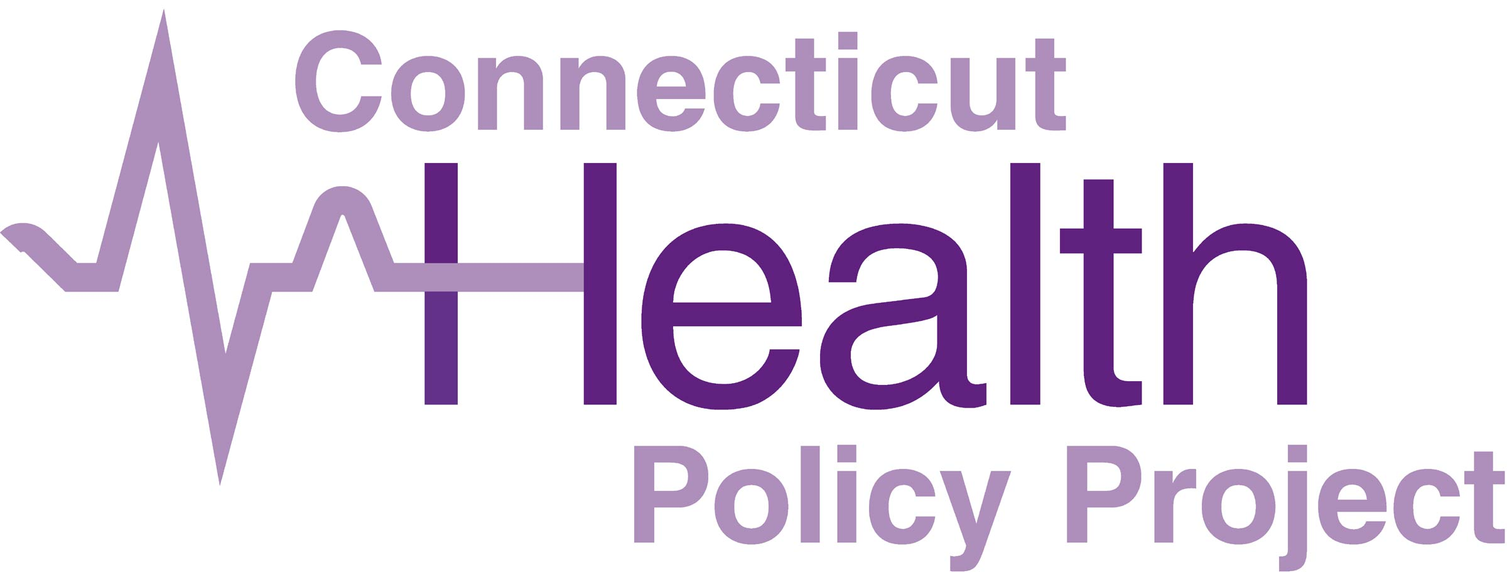

Why MCOs shouldn’t come back into HUSKY

Governor Lamont is reportedly considering a plan to have private insurance company managed care plans (MCOs) run Connecticut’s Medicaid program. From 1996 through 2011, Connecticut Medicaid was run by MCOs, and it was deeply troubled. The program ended under pressure from advocates, providers, and legislators. Since the MCOs left Connecticut Medicaid, access and quality of care have improved, and the state has saved billions of taxpayer dollars.

MCOs in HUSKY didn’t work
A state study found that 4 in 10 providers listed by the MCOs did not take MCO patients. Enrollment in MCOs was often suspended because they didn’t have enough providers. An audit found that the MCOs were overpaid by millions of dollars. Connecticut’s doctors sued the MCOs for engaging in deceptive and improper practices that harmed patients. The state couldn’t get data from the MCOs to hold them accountable.

MCOs don’t save Medicaid money
Connecticut taxpayers have saved billions of dollars since MCOs left HUSKY. We have the best cost control record in the US, and we spend just a third of what other states spend on administration. Over a dozen independent studies have found no evidence that Medicaid MCOs save money. Extra costs include profits, advertising, federal MCO taxes, MCO administration, DSS staff to manage contracts and get data out of MCOs.

MCOs don’t improve access or quality of healthcare
There is no evidence that Medicaid MCOs improve access to care or the quality of care. After the MCOs left HUSKY, cancer survival rates rose 8%. HUSKY now, without MCOs, is in the top quarter of states in 17 of 28 adult quality measures and 13 of 22 child quality measures.

HUSKY members have a lot to lose if MCOs come back
The quality of care could sink to the level of most states that have MCOs. It is likely to be harder to get appointments for care and there will be fewer providers accepting Medicaid patients. There will be more administrative hurdles to get the care you need. Current efforts to raise provider payment rates, improve primary care, and expand access to mental health and substance use treatment would be at risk. These problems would fall hardest on seniors, people with disabilities and communities of color increasing health disparities.

Contact Governor Lamont’s Office –
Tell him not to bring MCOs back into HUSKY
Phone: 800-406-1527
Email Governor Lamont

