Questions on maternity bundles

- Are bundles voluntary for providers?
DSS is changing payment for maternity services from a combination of global payments and fee-for-service to a bundled payment program. The program will be mandatory for certain maternal health providers. Providers who are not eligible to participate in the bundled payment program will continue to bill using a combination of global payments and fee-for-service for services rendered.

- Can patients opt-out?
HUSKY Health members can choose and change their provider - some of which will not be participating in the bundle.

- How will patients be notified that their provider is at financial risk for their care during pregnancy, delivery, and beyond?
DSS will conduct an information campaign to educate HUSKY Health members about the bundle program and the benefits available through HUSKY Health.

- What is the methodology and data source to determine the bundle amounts?
  - For historic spending – are you using Medicaid utilization and payment rates or commercial/state employee plan rates
The bundle price will consist of a blended rate using statewide and provider-specific utilization history, using Medicaid claims data.

- What systems are you using for medical and social risk adjustment?
DSS will apply risk-adjustment based on clinical risk and intends to incorporate social risk factors into the methodology as well. As the Department is still in the design phase, systems for medical and social risk adjustment are still under development and are slated for discussion with stakeholders this Fall.

- Are any other states using bundles for Medicaid labor/delivery that include inpatient costs? What is their experience?
Nearly all states include care related to labor and delivery within the maternity bundle. Many programs report decreases in medically unnecessary C-section rates among other benefits of this methodology.

- What are the cost assumptions/goals? Increased spending on doulas, etc.? Are you expecting cost neutrality or savings? What are the assumptions underlying your goals and where did they come from – other programs, literature?
Cost assumptions remain under development as DSS completes the design phase. Program goals include:
- Address racial disparities in maternal health and birth outcomes
- Reduce incidence of unnecessary Cesarean procedures and early elective births
- Support parity between OB/GYNs and certified nurse midwives
- Create access to doula services and enhanced lactation supports
- Align payment models across Medicaid and the State Employee Health Plan
- Create savings for DSS attributable to improved maternal and newborn outcomes

- What proportion of total payments will be based on quality? How are the payments weighted by quality metric and performance level – between total performance and improvement? We need to balance payments to consistent top performers with incentives for lower performers to improve. Medicaid covers a lot of CT births – we can’t afford to lose providers.
Quality metrics and how quality ties to payment are features that remain under development as DSS completes the design phase.

- What feedback/evaluation will you give providers during the year about their performance on costs and quality while they can still do something about it? This is especially important if inpatient and specialty care is included.
Providers will receive performance reports no less than quarterly that include actionable cost and quality data.

- What are the included and excluded services referred to in the Appendix slides? I’m assuming the bundle only includes pregnancy-related services. Is that true?
The maternity bundle will be inclusive of the services required throughout the maternity care experience (ie., prenatal, labor and delivery, postpartum). DSS aims to tie quality metrics to screenings, care coordination activities, and use of high-value support services to align clinical incentives.

Based on a set of guiding principles, the following table explains the current approach to determining what services are included or excluded.

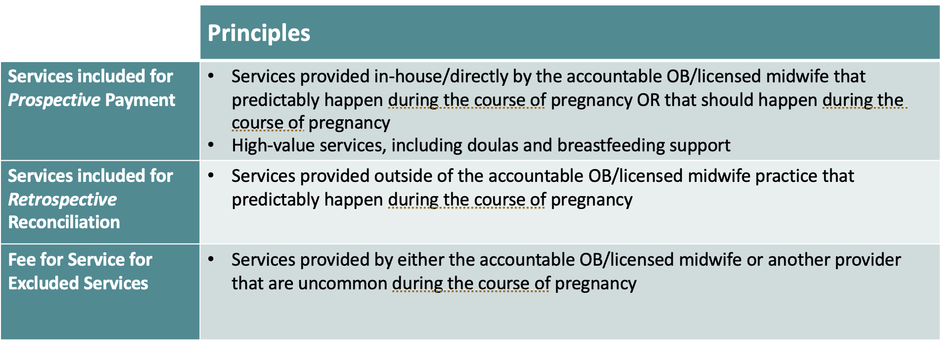

Note: Under the maternity bundle program, HUSKY Health members will retain full coverage to all Medicaid-covered services and benefits and gain new benefits, including doula care and breastfeeding support. Services “excluded from the bundle” will not have its associated costs of care factored into bundle payment pricing or reconciliation.

- Who exactly is at financial risk? The health system, that includes the hospital, or only the practice? Do you expect only practices affiliated with large health systems to be able to absorb this risk? How will the financial risk, and the quality incentives, be apportioned between the system and the practice?
  - You should monitor that balance to ensure that practices can do the right thing for patients, regardless of cost and to avoid cherry-picking
Maternal health providers practices will be held accountable for financial risk. In at least year one of the program, providers will be eligible for upside/shared savings only (no downside risk), enabling DSS to phase in financial risk over time as providers gain more experience with this program.

- Are you ensuring that private equity and other outside funders are not funding/directing the new arrangements?
DSS has no direct engagement with outside funders or private capital. Maternal health providers must meet CMAP enrollment criteria to participate.

- How will patients be attributed to the practice?
  - Prior care site, how much prenatal care do they have to get from the practice (or at all)
A bundle is triggered as soon as they have at least one claim for a prenatal care service during the first or second trimester. The goal is to improve access to timely prenatal care, but providers and the birthing person will not be penalized for a patient receiving care later in the pregnancy. Any member who does not seek care until the third trimester will be excluded from the bundle.
  - Can patients choose a site they haven’t seen before (maybe they couldn’t get in or want to change from their previous providers)
Yes, patients retain the choice to select the provider and care site of their choice.

- Do you intend to share the risk with pediatricians when you begin including newborns in the bundle? Is this where DSS intends to stop? This feels like a slow march back to capitation.
Newborn care is defined as services for the newborn from birth to 30 days following discharge from the facility. In Year 1, the bundle will include reporting only to participating maternal health providers for newborn care for the first 30 days. Pediatricians will not be responsible for financial accountability. The inclusion of newborn care in reporting will support tying the impact of prenatal care to post-birth outcomes, including NICU utilization.

- I would move patient experience of care up to the quality list from “Consider adding”? It is critical both for the data, and for providers to understand that part of their compensation is dependent on their patients’ experience. This should be through a gold-standard survey such as CAHPS, not a doctor-centered survey. This is especially true when adding non-doctor providers to the team.
DSS agrees that patient experience is a critical quality measure to collect and is currently evaluating the Pregnancy Risk Assessment Monitoring System (PRAMS) Survey as a potential tool. DSS has been working with Yale CORE to evaluate the best approach to build a quality measure for patient experience throughout the perinatal episode.

- What time are the advisory meetings listed in the appendix? Who is on the Advisory Committee?
The Maternity Bundle Advisory Council meetings typically take place on the 3rd Tuesday of every month at 11am. Committee attendees include HUSKY Health members with birthing experience, legislators, community-based advocates and organizations, providers (OB providers, certified midwives), and doulas. Stakeholder engagement efforts also include ad hoc subgroup meetings with doulas and providers to allow for additional time for design discussions. These meetings are streamed via the CT DSS YouTube Channel and recorded there.

- What is the attachment point for the bundle over which providers are no longer at risk?
The specific point at which highest cost bundles would be excluded remains under development as DSS completes the design phase.

- How will you monitor for underservice and cherrypicking? What data sources will you use – do you have enough information/data to identify underservice or cherrypicking
  - This is critically important and probably needs a separate document/presentation
DSS will use at least Medicaid/CHIP data and additional details will be laid out as part of the ongoing design process.

